F. INSTITUTIONAL COMMITMENT
The Massachusetts General Hospital is strongly committed to excellence in biomedical research. Supporting and growing the community of researchers who are making clinically relevant developments through the use of cutting-edge molecular imaging is an area of particular interest. Recognizing the need for translational capabilities within the hospital research environment, the hospital established the Institute for Innovation in Imaging, i³, in 2014. The i³ has been supported directly from the Chair of the Department of Radiology, Dr. Brink, with over $1,200,000 to provide salary support for staff with expertise in regulatory affairs, quality assurance, medical writing, clinical trial coordination, and chemical development. The Department of Radiology has also provided over $1,000,000 in additional funding to support core research services. The hospital and the Department of Radiology recently committed over $15,000,000 to the build out new space for the Insitute for Innovation in Imaging in the Charlestown Navy Yard Building 149. This construction project runs in two continuous phases. In the first phase which has just completed, the i³ faculty, researchers and staff have occupied 2322 square feet of space on CNY149-10. An additional 2310 square feet of shared support space consisting of conference, dining and storage space was also built. The research space on CNY149-2 consists of 3490 square feet that houses preclinical imaging, wet and dry laboratory research and development space, and a cGMP production facility to produce radiolabeled imaging probes for clinical PET imaging.
Specific to this shared instrument, the Institution has made the following commitments:
- Currently building a cGMP PET production facility with a 1) production radiochemistry room where the shared instrument will be housed, 2) a clean room for preparation of radiopharmaceutical (Ga-68 based) doses for human use, 3) a quality control lab, 4) a controlled inventory space, and 5) associated soft space for documentation. This facility is part of a $15,000,000 expansion and represents a major commitment to this instrument. See letters of support from Drs. Orf and Brink.
- MGH Radiology has provided over $1,000,000 to support the i³ Research Core which includes support for staff who will be responsible for the shared instrument. See letter of support from Dr. Brink, Chair of Radiology
- The MGH Executive Committee on Research has provided $100,000 exclusively dedicated to support this shared instrument. See letter of support from Dr. Orf, Senior Vice President for Research at MGH.
The cGMP production suite is comprised of the following; a controlled access central corridor, an inventory quarantine room, a controlled inventory room, a quality control measurement room, a cleanroom, an ante-room to the cleanroom, and a production radiochemistry room (Fig. 22). The requested equipment will be housed in the production radiochemistry room. In addition to this 3490 sq ft of dedicated space, the i³ is also sharing 3310 sq ft of space with another program (Integrated Brain Consortium) to establish the new clinical and translational research unit (CTRU). This comprises exam and evaluation rooms, clinical laboratory, PET dosing, reception and patient waiting rooms. Human imaging studies are performed on the first floor of Building 149 (CNY149-1) as well as on the MGH Main campus. There is further institutional commitment to this piece of instrumentation in that the Department of Radiology and the i³ have committed to all the necessary equipment required for formulation and dosing (in the clean room) and for all the analytical quality control testing (in the QC lab) that is necessary for preparing doses of Ga-68 based radiopharmaceuticals for human use. Please see letter of support from Dr. James Brink, Chief of MGH Radiology.

The Ga-68 automated radiotracer production system will be sited in the production radiochemistry room witihin the Institute for Innovation in Imaging cGMP suite. This room is designed to house 3 different radiotracer production systems that will enable research and development of products utilizing different radioisotopes (Ga- 68, Zr-89, Cu-64) through dedicated equipment. The room also contains a lead lined hood and bench space for production preparation of solvents and other materials. The production room is across the central corridor from the controlled inventory room where solvents, buffers and disposable components necessary production runs will be stored and inventoried in a cGMP manner. The production room is an iso-8 room with an independent HVAC system and constructed with walls, floor and ceiling that can be easilty decontaminated through routine cleaning. The production room also has a pass-thru into the iso-7 cleanroom where clinical dosing is prepared in iso-5 level laminar flow hoods. Thus, clinical dosing can be prepared through cGMP production and preclinical radiotracers can be prepared in the same manner that will be translated into future clinical use.

MGH has commited has also generously supported the Athinoula A. Martinos Center for Biomedical Imaging throughout the years. The Institute for Innovation in Imaging research space will be on floor 2 of building 149, directly above the Martinos imaging suites. The Institute for Innovation in Imaging is closely aligned with the

Martinos Center and will utilize the recent institution-wide investment in new state-of-the-art molecular imaging facilities, which have added a detailed ‘molecular arm’ to complement the other imaging methods within the Martinos Center. This has included two large-bore MR-PET scanners, a micro-PET-CT, a small bore 4.7T MRI with a PET insert for simultaneous MR-PET, a cyclotron, radiochemistry production facility, and a cGMP radiopharmacy for manufacture of ¹¹C, ¹³N, ¹⁵O, ¹⁸F radioligands. The mission of the Institute for Innovation in Imaging was designed to complement, augment and expand the exisiting imaging core in the Martinos center. The cGMP suite within the i³ is designed to utilized long-lived and generator produced isotopes that do not depend on the onsite cyclotron. In this way cyclotron usage and radiotracer production can be maximized to make full use of the scanner suites. Our close relationship with the Martinos Center ensures that researchers using Ga-68 radiotracer production performed within the Institute for Innovation in Imaging will have access to all the state of the art imaging and clinical assessment tools. Please see letter from Dr. Bruce Rosen, Director of the Martinos Center. The new i3 core and site of this instrument will be one floor above the imaging instruments housed within the Martinos Center (Fig. 23)

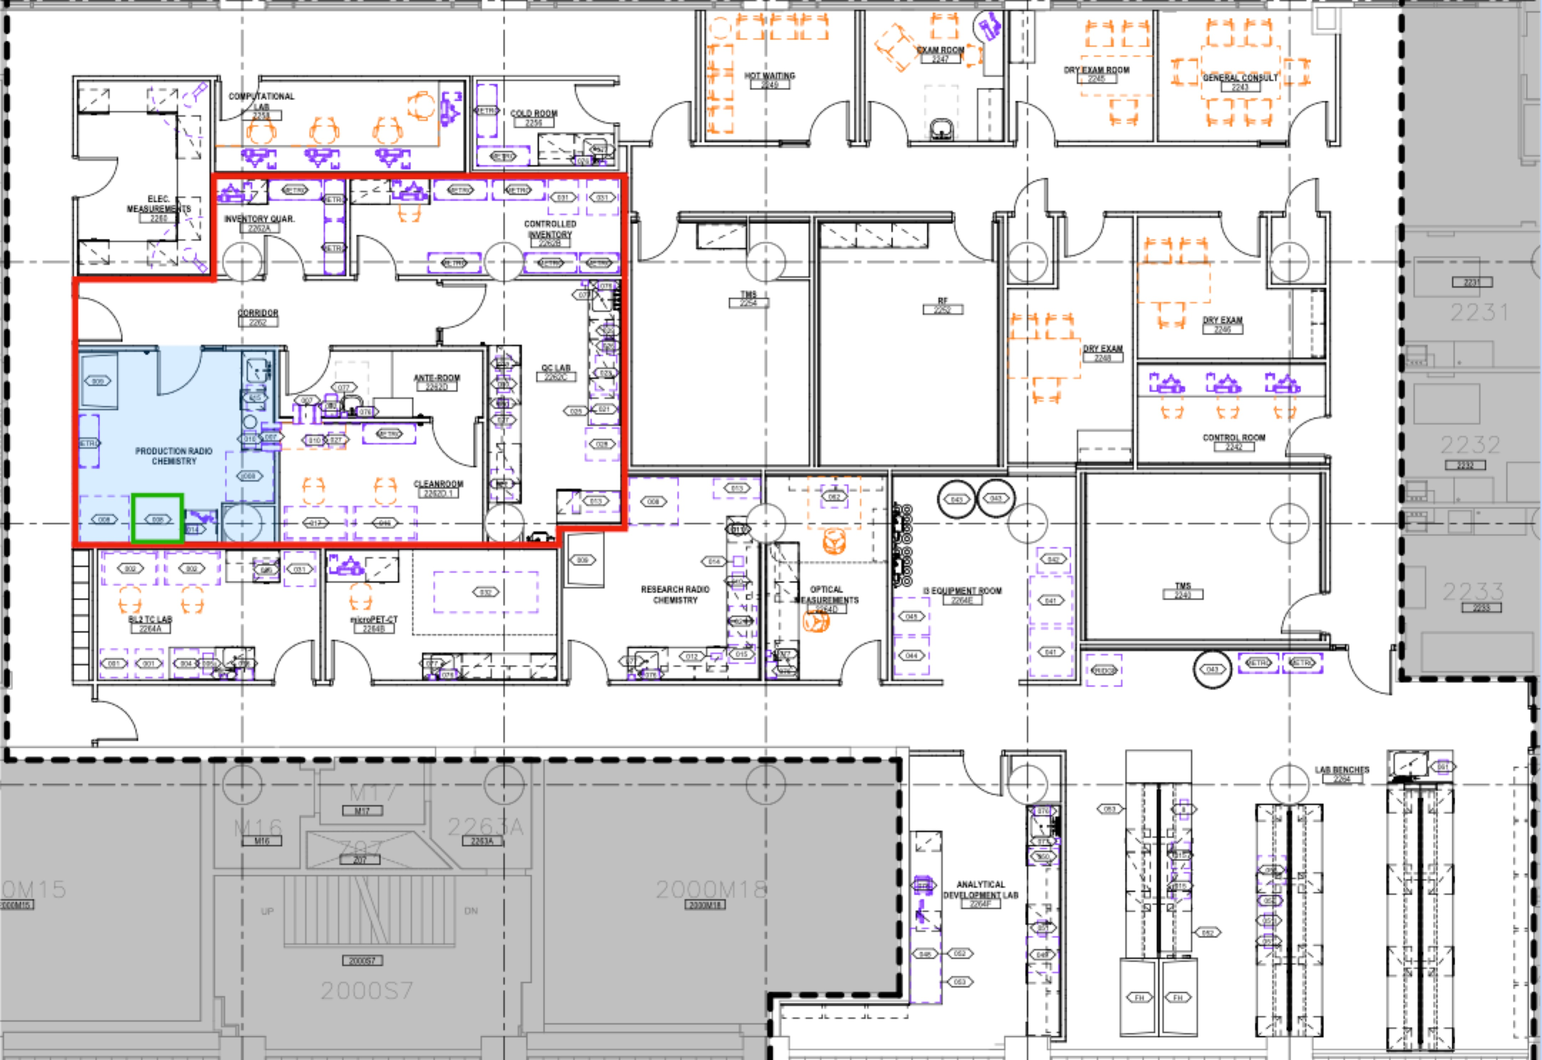
Figure 22. The Institute for Innovation in Imaging research and development space. The research space includes a state of the art cGMP facility (red outline) that houses inventory quarantine, controlled inventory, QC, Ante cleanroom, cleanroom, production radiochemistry and controlled access corridor rooms. The Ga-68 production system will reside in the iso-8 Production Radiochemistry room (blue) and will be one of three dedicated radiotracer production units. The hot cells which contain the synthesis/generator have been designed into the architecture plans (green outline).

Recognizing the impact the proposed instrument will have on both actively funded research projects and new research directions likely to grow from the availability of a dedicated Ga-68 radiotracer production system, the MGH Executive Committee on Research (ECOR) has committed to contributing institutional funds in the amount of $100,000, as attested to in the letter supplied by the Hospital’s Senior Vice President for Research,

Dr. Harry Orf. These funds will be used to cover operating costs like the service contract and support for a technician to operate the instrument. The cGMP facility at the Institue for Innovation in Imaging, currently being built by the hospital, was designed to house multiple radiotracer production systems, therefore there are no anticipated siting costs associated with this instrument.
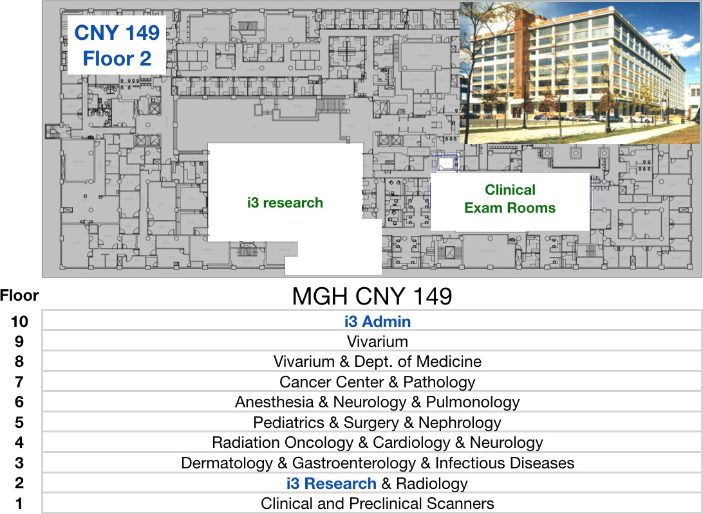
Figure 23. Location of i³ research within the MGH research building CNY-149. The i³ research space where this instrument will be housed is located on the second floor of building CNY-149. Production of Ga- 68 probes will be performed here adjacent to clinical space for patient studies. All imaging instruments (human and preclinical) are located on floor 1, while the vivarium is housed on floors 8 and 9.

