A. JUSTIFICATION OF NEED A1. Background

The Institute for Innovation in Imaging, i³, within the Department of Radiology at Massachusetts General Hospital (MGH) was founded to accelerate the translation and adoption of novel imaging probes, devices, and imaging methodologies developed within the department. The mission of the i³ is threefold: to provide the resources necessary to develop and validate new imaging technologies in preclinical experiments; to provide the space, expertise and resources necessary to translate new imaging technologies into first in human experiments through the appropriate regulatory processes; and to provide validated current Good Manufacturing Processes (cGMP) to manufacture molecular probes (e.g. positron emission tomography (PET) tracers) for clinical trials using the vast array of clinical imaging instrumentation available at the MGH.

The Department of Radiology at MGH is the largest academic radiology research site in the US and is home to several internationally recognized Centers for research, among them: the Martinos Center for Biomedical Imaging (Bruce Rosen, Director), the Center for Systems Biology (Ralph Weissleder, Director), the Gordon Center for Medical Imaging (Georges El Faqhri, Director), the Center for Ultrasound Research Technology (Anthony Samir, Director). While these major research centers, as well as other groups with the Department, perform innovative preclinical and clinical research, it was recognized that translation of new imaging technologies from bench to clinic was performed ad hoc. In
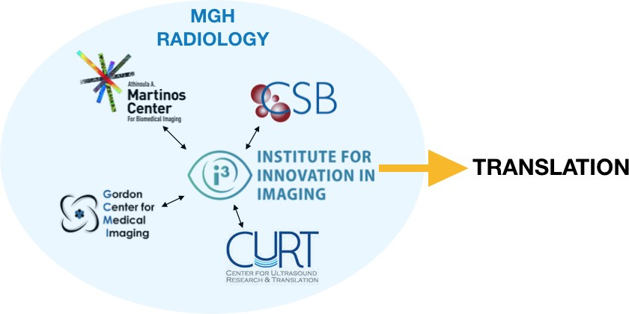
2014, the i³ was formed to help Radiology researchers from these centers to translate their new innovations into clinical research and ultimately commercialization (Fig. 1). The i³ is a complementary asset to these major Centers and does not duplicate efforts/infrastructure found in those Centers. Rather the i³ fills gaps in translational research. i³ faculty are drawn from these major research Centers and utilize resources both within the i³ and their Center. For example a researcher may
leverage i³ chemistry and regulatoy resources to obtain FDA

approval to test a novel PET tracer in humans, and then scan those subjects on a PET/MRI scanner in the Martinos Center.
Figure 1: The role of the i³ within MGH radiology research

To this end, the i³ has already shepherded four novel PET imaging probes, invented at MGH through the investigational new drug (IND) process and institutional review board (IRB) approval into clinical trials for projects supported by the NHLBI, NCI, NINDS, and NIMH. The i³ has also facilitated the establishment of 2 other PET tracers into the MGH for clinical research for projects supported by NCI and NIDA. The i³ is currently working with investigators to translate 3 more novel tracers by the the end of 2020. These new probes are being used to detect disease, to stage disease and provide prognostic information, to monitor the effectiveness of therapies, and to study questions of fundamental human biology.

Recognizing the achievements of the i³ and the value created to date, the MGH and the Department of Radiology have committed over $15 million to establish and build out a state of the art translational research facility for the Institute for Innovation in Imaging. This expansion will allow the i³ to greatly increase its ability to serve the MGH community as well as academic and industrial partners within the Massachusetts life sciences ecosystem. Highlights of this expansion include: 1) a cGMP manufacturing facility for PET tracers; 2) a preclinical probe development and testing lab; 3) analytical chemistry facility; 4) office space for staff, regulatory affairs, and medical writing; 5) a clinical and translational research unit (CTRU) with exams rooms and nursing staff; 6) a computational lab for image analysis. The expansion is underway with move-in for Phase 1 completed in July 2019 and Phase 2 is currently underway. The i³ Core Research facility, supported by an additional >$1,000,000 investment from the Department of Radiology will go online in October, 2020 (the start of our fiscal year) with 7 initial services offered.

The i³ faculty and staff have expertise in MR, PET, SPECT, optical, and ultrasound imaging modalities as well as radiochemistry, synthetic chemistry, hardware development, software development and image analysis. The faculty was assembled from multiple clinical departments at MGH including, Radiology, Cardiology and Nuclear Medicine. The Institute has close associations with multiple research centers within MGH including the Martinos Center for Biomedical Imaging and the Center for Systems Biology. The new research space includes electronics development space, tissue culture, microPET-CT, optical microscopy, research radiochemistry,

analytical lab, standard wet lab bench space and a cGMP radiotracer production facilty with GMP radiochemistry, clean room, and quality control lab (see Fig. 22 in the section F. Institutional Commitment). This space is combined with the clinical and translational research unit which provides exam rooms from patient dosing and monitoring as well as a ‘hot’ waiting room where subjects await imaging procedures.

The Institute for Innovation in Imaging is a major hospital-wide initiative to expand the impact of cutting-edge imaging research performed at MGH through a pathway to clinical translation. Located in the Charlestown Navy Yard research campus of the MGH, approximately 2 miles (a 20 min shuttle bus ride) from the main MGH campus, the i³ was designed to leverage MGH’s existing research imaging arsenal located within the Martinos Center for Biomedical Imaging. This includes 8 large bore MRI scanners dedicated for human research studies operating at 3 or 7 tesla. Relevant to this proposal, two of these 3 T scanners have simultaneous PET imaging capability. For high resolution rodent imaging there is a simultaneous 4.7 T MRI/PET system, a micro-PET and adjacent micro-CT system, and additional small bore MRI and optical imaging scanners. In addition, there exists magnetoencephalography (MEG), electroencephalography (EEG), near infra-red spectroscopy (NIRS) diffuse optical tomography (DOT), and computed tomography scanners for human research studies. Within the Gordon Center on the 5th floor of the same building is a micro-PET/SPECT/CT scanner for additional animal research. The automated Ga-68 radiotracer synthesis instrumentation that is the focus of this application will be utilized by users who have access to this suite of scanners. It will sit on the 2nd floor and produce Ga-68 radiotracers for use with the scanners on the 1st and 5th floors. Scheduling for the i³ core is shared with the Martinos scheduler (see section E), so scheduling projects that rely on Ga-68 probe production and imaging is seamless.

The MGH Charlestown campus is also home to researchers from every department and division within the MGH, and there are a large number of programs that use imaging as a primary of secondary tool, many of which may utilize this shared resource in the future. For instance, the Martinos Center scanners support over 200 PHS-funded research projects at the MGH and other Boston-areas institutions, as well as other institutions in the United States and abroad. There are several large-scale research initiatives, including the NIH Blueprint- funded Human Connectome Project, the NCCAM-sponsored Center of Excellence for Research on Complementary (CERC) and Alternative Medicine, the Center for Systems Biology (CSB), the MGH Stroke Center, the MGH Institute for Neurodegenerative Disorders, the MGH Alzheimer’s Disease Research Center, the Center for Morphometric Analysis, and the MGH Psychiatric Neuroimaging Program, the Transplantation Biology Research Center, and the MGH Cardiovascular Research Center. An extensive network of researchers affiliated with the NIH CTSA-funded Harvard Catalyst Clinical and Translational Science Center also routinely utilize the imaging resources in Charlestown, and collaborations with investigators from MIT, Harvard University, Boston University, Tufts, and other Boston-area biomedical research hospitals and institutions extend the use of these vital resources further still.

A2. The Need for the Proposed Instrument
A leading research hospital, Massachusetts General Hospital is known worldwide as home to one of the world’s preeminent molecular imaging research programs, and has been at the forefront of developing new molecular imaging techniques and contrast agents. During the past decade investigators in the Department of Radiology have implemented several innovative methods for targeted molecular imaging and the identification of biomarkers for various disease states. These advances have relied critically on access to research radiochemistry development, cGMP production of radiotracers for human use and access to clinical imaging instruments. The i³ was established to expand molecular imaging development within the Department of Radiology and throughout the MGH. The i³ is expanding into new space to meet these instutional needs and the proposed automated Ga-68 radiotracer production system will enhance the capabilities of PET tracer production for clinical research. Gallium-68 is becoming more prevelant as a radioisotope, in part due to advances in chelation chemistry and increased use of peptides, biologics and nanomaterials as molecularly targeted and delivery tools. Yet, multiple NIH-sponsored research projects are limited by access to dedicated Ga-68 radiotracer production at the MGH Charlestown campus. To overcome this limitation we propose to address this need through acquisition of automated Ga-68 radiotracer synthesis instrumentation to enhance current research projects, enable clinical translation of promising molecular imaging agents being developed and provide a critical resource for future research and development.

Gallium-68 has ideal properties as a PET radiotracer. Gallium-68 was one of the first PET imaging positron- emitting radionuclides during the development of PET imaging. However, the production methods, which required EDTA chelation limited tracer synthesis and thus other radionuclides were adopted. More recently Ga- 68 generators, such as the GalliaPharm, have optimized production of Ga-68 for chelation-based labeling of tracers and generated renewed interest in using Ga-68 as a positron emitting source. Ga-68 has a half life that is well-matched with the pharmacokinetics of peptide and small nanoparticle compounds. This half life (68 minutes) enables improved dosimetry and repeatable imaging in clinical subjects. Ga-68 also has 89% decay through postiron emission. The labeling chemistry of Ga-68 through chelation provides rapid labeling of a variety of targeted probes. Exemplified by the projects in this proposal, these probes can include nanoparticles, peptides and small molecules. Ga-68 labeling is rapid and repeatable, which greatly enhance synthesis of radiotracers. Furthermore, the simple labeling procedure enables labeling of tracers where the complex chemistry required for C-11 or F-18 labeling takes too long to achieve clinical utility. Thus, Ga-68 is an ideal radionuclidic label that is increasingly popular as generation and synthetic chemistry methods are improving.

Existing facilities were not designed to produce Ga-68 labeled tracers. Two radiopharmacies exist at MGH for the production of PET radiotracers. (Martinos Center and Gordon Center). The Gordon Center facility is located on the main MGH campus and focuses largely on production of approved radiopharmaceuticals for use in clinical practice and some clinical trials. The Gordon Center mainly produces F-18 labeled tracers (e.g. FDG). However, use of the main campus Gordon Center facility and equipment for the production of Ga-68 tracers is mainly limited by: the high clinical demand for FDA approved tracers which limits the time available to produce novel tracers under cGMP conditions for clinical research studies; the transport time of Ga-68 tracers from the MGH main campus to the Charlestown Navy Yard research facilities where the research-only dedicated human PET scanners reside; the significant time and effort required to produce Ga-68 from the cyclotron that would limit current production capabilities, already close to maximum usage; and, the time and effort to convert synthesizers designed for F-18 labeling for use with Ga-68.

The Martinos Center radiochemistry cGMP facility is located in the Charlestown Navy Yard and designed to produce C-11 and F-18 radiotracers for human research studies. We have used this facility to produce ⁶⁸Ga- DOTATOC (PI = Mahmood) and ⁶⁸Ga-CBP8 (PI = Caravan) under NIH funded projects for clinical research. However, the Martinos Center cGMP facility is designed around its 11 MeV cyclotron that produces C-11 and F-18, which are then incorporated into radiotracers and formulated in the facility’s cleanroom. For radiotracers using isotopes like Ga-68 which can be produced by a small Ge-68 generator or longer lived isotopes like Cu-
64 or Zr-89, there is no need for an onsite cyclotron, but a cleanroom cGMP facility is still required for producing doses for human use. The i³ recognized that a second cGMP PET tracer production facility dedicated to long lived (e.g. Cu-64, Zr-89) or generator produced (Ga-68) radionuclides would enable optimal use of the large bore PET scanners and maximize C-11 or F-18 production from the cyclotron. That is, the existing Martinos Center PET production facility would focus on producing C-11 and F-18 tracers for clinical research and the new i³ GMP lab would produce Ga-68, Cu-64, or Zr-89 tracers. Together production from both facilities would maximize the production of novel and non-commercial tracers, and also maximize our human PET imaging capacity. Under our current arrangement it is not feasible to meet the needs of both Ga- 68 and existing C-11/F-18 radiochemistry within the same instrumentation and to have high utilization of the PET scanners. As a result this proposed equipment would facilitate and accelerate a number of NIH funded projects.

Gallium-68 radiotracer production requires a local Ga-68 source and local cGMP production. The half life of Ga-68 is 68 minutes, which has ideal properties for PET imaging, but greatly limits options of production. Unlike longer-lived radioisotopes (e.g. Cu-64 or even F-18) there is a limitation to shipping Ga-68 tracers because of the short half life and the relatively low yield of Ga-68 activity from the generator. The proposed system will be housed in the cGMP facility within the i³ facility on the second floor of Charleston Navy Yard building 149, enabling complete and rapid production of Ga-68 radiotracers with direct access to microPET scanners for preclinical evaluation and to the large bore PET-MR scanners on the first floor for evaluation in human subjects.

Clinical translation requires dedicated equipment to ensure quality and timely production of Ga-68 tracers. Production of radiotracers for human use requires dedicated facilities that ensure repeatability of production, accuracy of synthesis and sterility and purity of the final production. A key component of this is an automated

process to ensure reproducibility and also to minimize radiation exposure to operators. The MGH has committed substantial resources to build the cGMP production facility within the i³ where the proposed system will be housed. This unique resource will serve several purposes for research and translation. 1) Preclinical: the Ga-68 production system provides automated production with necessary quality controls to ensure preclinical experiments are repeatable and directly translatable and comparible to clinical evaluation. 2) Translation: the production system located within a cGMP facility provides the necessary equipment to generate validation data for IND application and approval, and then subsequent imaging in clinical trials in patients. To advance beyond research and development and bring new imaging tracer technologies into the clinic it is essential to have a dedicated Ga-68 automated production system housed within the i³ cGMP facility.

Ga-68 radiotracers have an increased regulatory burden
Recent regulations from the Nuclear Regulatory Commission and the Massachusetts Department of Health now require that any Ga-68 radiotracers used in human studies must contain < 0.001% Ge-68 breakthrough/contamination. The Gallia Pharm generator proposed in this application meets this requirement where generators from other suppliers (e.g. ITG) do not.

In this proposal, we request funding to acquire a Ga-68 automated radiolabeling instrument for development and clinical translation of PET imaging tracers. We propose to purchase the combination a hot cell from Comercer with a combination synthesis (PharmTracer) / gallium generator (GalliaPharm) from Eckert-Ziegler. Each component is essential to complete the Ga-68 production system and either independent of the other would not enable Ga-68 radiolabeling.

  - Description of the Proposed Instrument – cGMP automated Ga-68 radiotracer production system. With this application, we request funding to support the purchase of the necessary components that comprise a Ga-68 radiotracer production system. We sought to find a single vendor to obtain such a system, but in a highly specialized cGMP PET tracer production field no single vendor provides all the necessary components. Thus we will combine a state-of-the-art dual hot cell (Comecer) with a 50 mCi GalliPharm generator and PhamTracer automated synthesizer (Eckert Ziegler). This instrument will be used to reproducibly and safely produce Ga-68 labeled compounds in an automated approach to acheive cGMP necessary for clinical use.

Instrument Overview of the PharmTracer/GalliaPharm
Modular Lab PharmTracer
The Modular Lab PharmTracer was designed to allow versatile as well as efficient routine production of radiotracers complying with cGMP requirements. The system allows for necessary changes during early stage development but can subsequently “lock-in” the process for routine, reproducible production. Thus, the Modular Lab PharmTracer is the ideal platform for development and production of radiotracers. The system uses disposable casettes that enable production of different tracers within the same setup, but without risk of cross contamination. The PharmTracer runs with the patented Modular Lab software (Fig. 2). The graphic user interface with drag and drop graphical symbols is

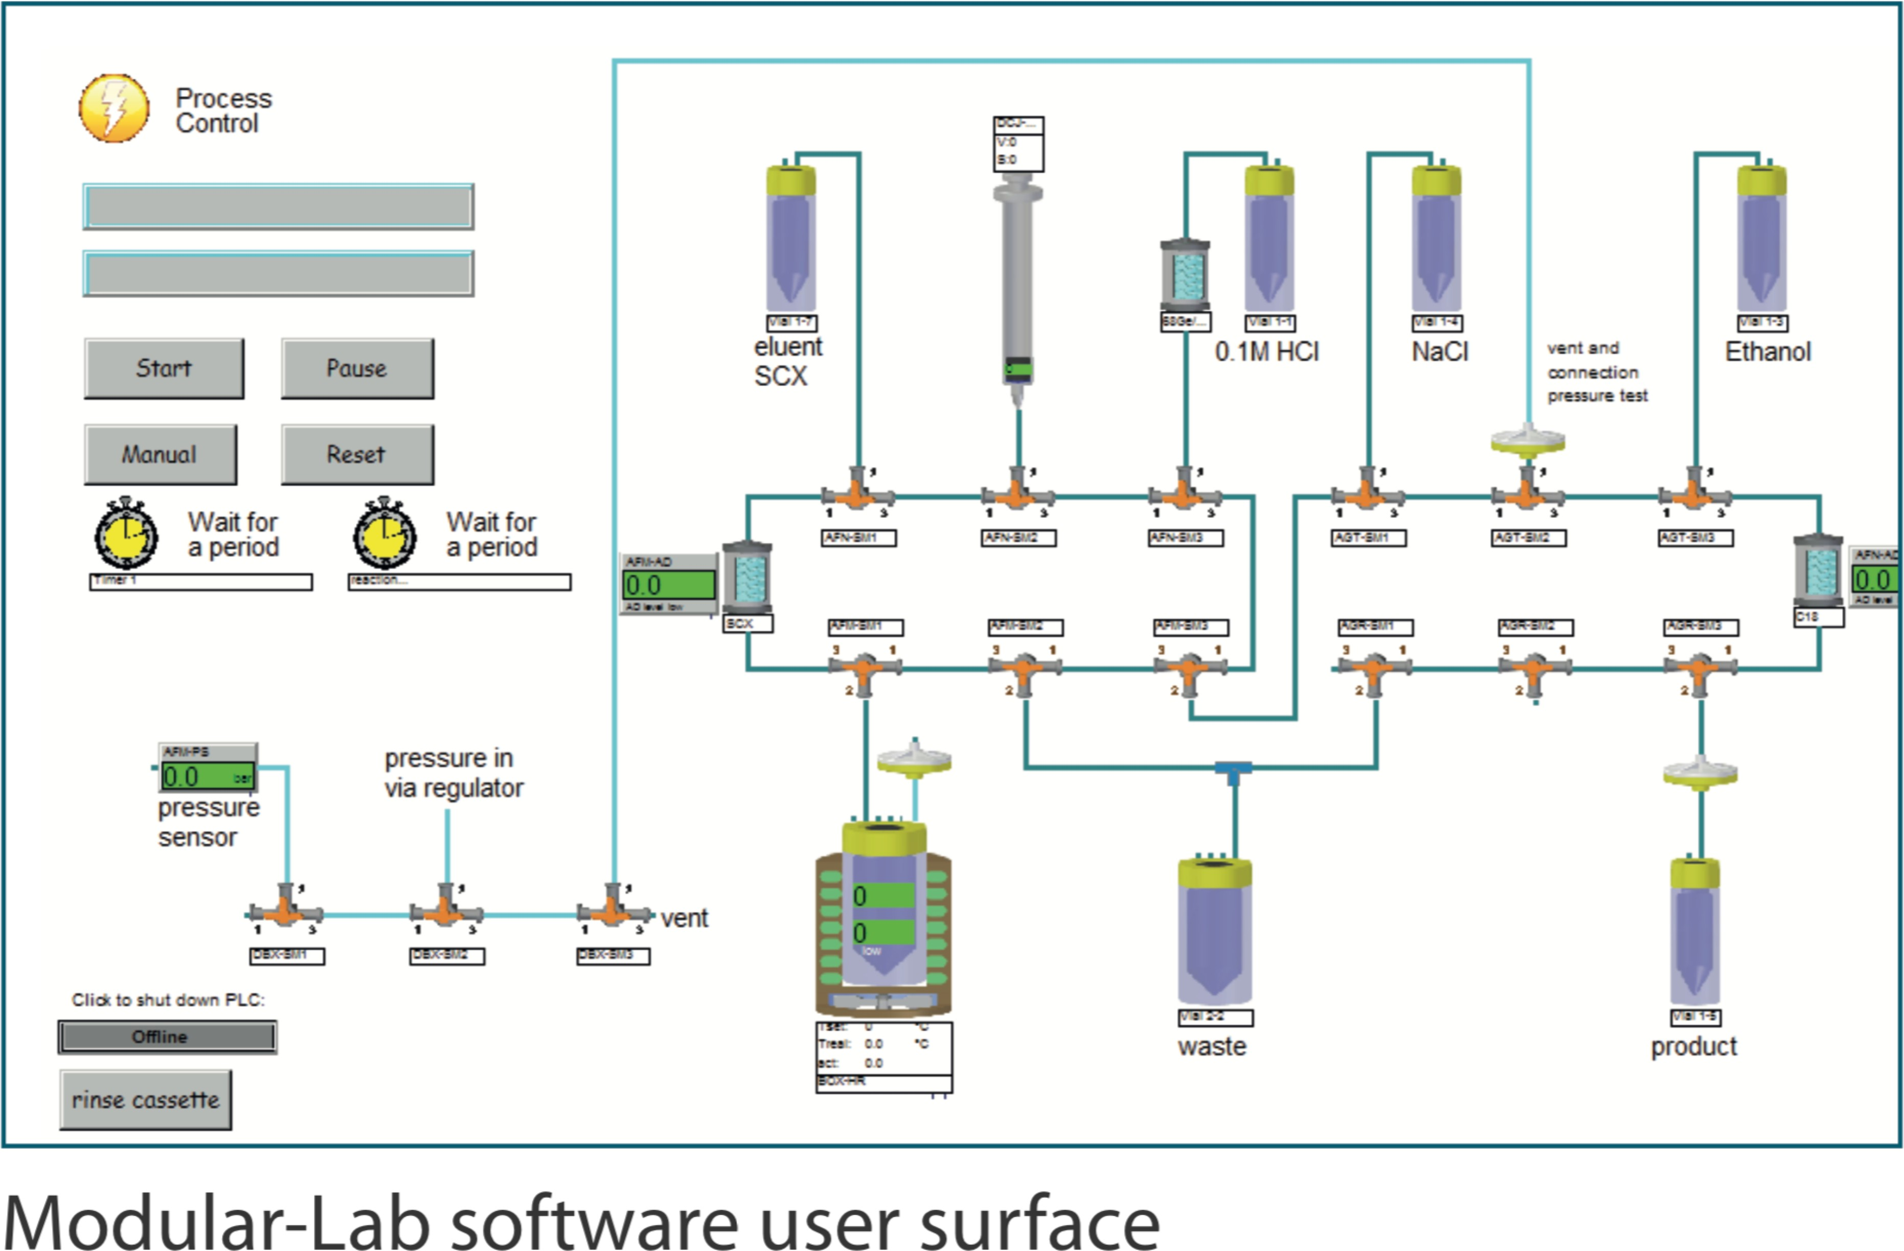
Figure 2. The control software for the PharmTracer automatic Ga-68 radiotracer production system.

compliant with GMP, cGMP, GAMP 5 and 21 CFR part 11 regulations. The unique combination of the speed and safety of a remote, fully-automated system with the option to configure synthesis for novel tracers allows the PharmTracer to meet the demands of dozens of radiotracer production projects. Use of GMP manufactured sterile disposable cassettes avoids intense cleaning and sanition which limits downtime, producing increased run capacity. The software precisely controls parameters including temperature, activity detector readings, flow

rates and valve settings. Reports containing all relevant data and information are automatically created for each run.

GalliaPharm
The GalliaPharm 68Ge/68Ga Radionuclide Generator is a pharmaceutical product for obtaining the positron emitter Ga-68, independent of a cyclotron. GalliaPharm reliably produces high purity Ga-68 for cGMP labeling and radiotracer production (Fig. 3). GalliaPharm is a closed system consisting of pharmacopoeia grade borosilicate glass column containing a titanium dioxide bed on which Ge-68 is adsorbed. Ga-68 is continuously produced through decay of its radioactive parent Ge-68 and is eluted with sterile ultrapure 0.1 mol/L hydrochloric acid. Each GalliaPharm unit is produced under GMP conditions to ensure the highest quality standards. It is designed to minimize both Ge-68 breakthrough and metal impurities – no metals are used within the enclosed system. The GalliaPharm unit meets the standards set by the US Nuclear Regulatory Commission and the Massachusetts Department of Health for human use of Ga-68 labeled tracers.

In the USA a 68Ge/68Ga generator is regarded as a

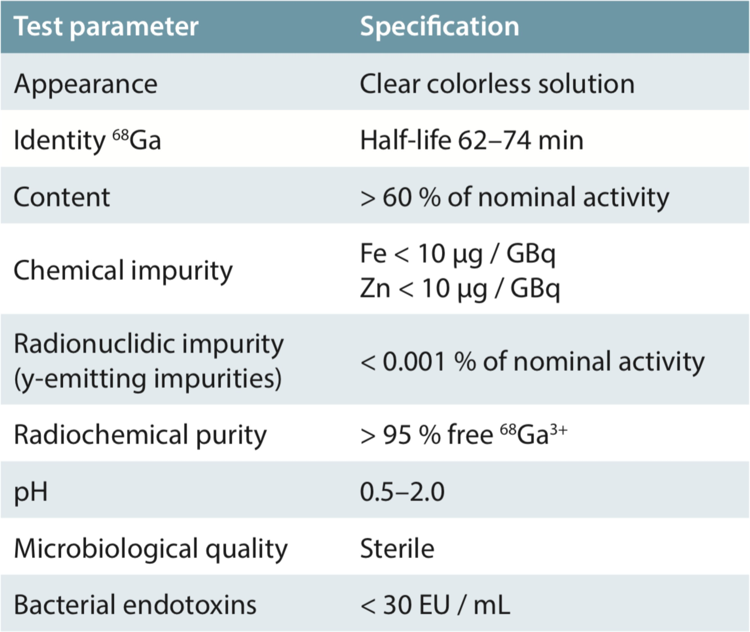

Figure 3. Properties of the GalliaPharm Ga-68 generator.

drug substance. Eckert & Ziegler Radiopharma GmbH is holder of a Type II Drug Master File (DMF #28741) for GalliaPharm and has successfully completed inspection by the FDA. The DMF can be referenced in any New Drug (NDA) and Investigational New Drug (IND) applications that use GalliaPharm for Ga-68 radiotracer production. The sterile ultrapure 0.1 mol/L hydrochloric acid provided by Eckert & Ziegler Radiopharma GmbH is subjected to its own release procedure. The generator achieves 100% yield within seven hours of elution. Yet, importantly 90 % yield will be achieved after four hours, which produces enough activity for clinical use.

A3.2. Description of the Proposed Shielded Hot Cell.
The BBS Series Hot Cell for synthesis module is a 100 mm lead shielded epoxy-coated carbon steel chamber designed to house synthesis modules and generators designed to guarantee radioprotection to the user during production of radiopharmaceuticals and radiotracers. The hot cell layout and components ensure utmost decontamination and cleaning effectiveness to enable cGMP production. This two cell vertical configuration will house the PharmTracer and GalliaPharm components in separate cells to prevent contamination of the generator. The chambers are under constant negative pressure with an inlet filtration system made from a HEPA absolute filtering cartridge with 99.995% efficiency and outlet filtration system made from a active carbon filtering cartridge – air quality complies with Class B “At rest” (EEC-cGMP). Shielding elements on the doors and chambers are made with primary ingots (Pb 98% + Sb 2% purity). The hot cells are also equipped with a 7” touch-screen operator panel to check and trace the critical parameters of the machine both in "at rest" or "in operation" mode. A smart Gieger HC radiation monitor detects radioactivity inside the hot cells and locks the doors when dose rates rise above a preset threshold. The monitor can also be configured to monitor the outlet air duct to ensure radiation is contained to the hot cell.

A3.3 Comparison with competing instruments
There are four known vendors that produce Hot Cells suitable for cGMP Ga-68 labeled radiotracer synthesis. Each system is capable of housing the generator/synthesizer instrument that completes the automated production system. However, only the Comercer model was designed to work with both production and development radiotracer synthesis. This system enables both controlled, highly automated production, but also user interactive development and optimization. This system also meets all the other requirements.

Table 1 Comparible Hot Cells
Vendor | Production/Development | Lead | Decontamination | Viewing | Unique Safety

 |  | Lining | Features | Options | Features
Capintec | Development focused | 75 mm | Rounded internal  corners | Camera | Real time  monitoring
Trasis | Development focused | 45 mm | Compact | Lead lined  glass | Iso-5 or 7
Ultraray | Production focused | variable | Standard stainless  steel | Lead lined  glass | Iso-5
Comecer | Both | 100 mm | Minimal corner  design | Camera | Leak test

There are four known vendors that produce synthesizers for automated Ga-68 radiotracer production. Three of the synthesizer components meet our requirements for automated cGMP production. However, of the four vendors only Eckert Ziegler and ITG produce Ga-68 generator combinations. Unfortunately the ITG generator does not comply with new regulations from the Nuclear Regulatory Commission and the Massachusetts Department of Health that require any Ga-68 radiotracers used in human studies must contain < 0.001% Ge-
68 breakthrough/contamination. Therefore, the only instrument that meets all of the requirements for our system is the combined generator/synthesizer from Eckert Zeigler.

Table 2 Comparible Generator/Synthesis Instruments
Vendor | Optimized for Ga-68 | Generator-  Synthesizer Combination | <0.001% Ge-68  Breakthrough | Cassette Based | Live Monitoring | Report Generation | Novel  Tracer Capability
ITG | ✔ | ✔ |  | ✔ |  | ✔
Trasis |  |  |  | ✔ | ✔ | ✔ | ✔
Iba | ✔ |  |  | ✔ | ✔ | ✔ | ✔
Eckert  Zeigler | ✔ | ✔ | ✔ | ✔ | ✔ | ✔ | ✔

  - Inventory of Local Instrumentation and the Need for Proposed Instrument
In the Boston area there are 4 other cGMP radiotracer production facilities used for research radiotracer development and clinical testing. Two at MGH (Gordon Center and Martinos Center), one at our sister institution the Brigham and Women’s Hospital, and one at the Dana Farber Cancer Institute. A radiotracer production group consisting of the 3 MGH facilities and the BWH facility has been established under the leadership of the Chief Radiologists at MGH and BWH. This highly collaborative group meets monlthly to discuss common issues in production and regulatory changes to ensure that each facility is operating at the highest standard. The group also shares resources when possible and necessary to assist each facility as needed. The facility at the Dana Farber Cancer Institue is being converted from a more radiopharmaceutical production focused facility to one capable of performing clinical radiotracer research and has thus not yet been included in the working group. Each of the facilities has common and unique capabilities, yet none have dedicated Ga-68 production capacity. While they all are capable of production of Ga-68 labeled radiotracers, the extensive cost, effort and resulting downtime from currently active production (C-11, F-18 labeled tracers) greatly limit Ga-68 radiotracer production to highly critical cases and is not sustainable for long term production
– especially as the demand for Ga-68 labeled radiotracers increases.

A5. Accessible User Time (AUT).
Use of the instrument will be divided into three categories: 1) GMP production for clinical imaging; 2) probe development and preclinical research; and 3) use of Gallium-68 isotope outside the i³ facility. GMP production will be performed by highly trained staff in a controlled environment and receive access prioritization the instrument. For all use categories 2 production runs can be performed each day. Thus all access will be categorized as productions with 2 productions a day. We anticipate access 5 days a week (weekends are restricted because GMP production is a controlled facility) with 2 days of down time every quarter and a full week at the end of the fiscal year (September 30) for thorough cleaning and maintenance of the equipment. Therefore, we will have the capacity for 250 days of use totaling 500 productions. Should demand exceed production for any given week, we have the capacity to perform 3 productions per day and can adjust scheduling as necessary, however we anticipate 2 productions per day will meet the starting demand. Initially

we anticipate 8 requests each week for a total of 400 productions a year. This estimate provides the necessary access for each project, enables flexibility should unexpected maintanence arise and provides opportunities for new, unfunded to access the instrument to generate preliminary data. Of these expected productions, we anticipate 140 will be for GMP probes, 230 will be for development and preclinical research, and 30 will be for other research. GMP productions will be grouped over 2-3 days (depending on demand) each week to limit the impact of any potential delays from research use. Productions for development research will provide access to the facility, instrument and Ga-68 isotope for half of a day. This time will provide ample time to label and analyze new probes – should extra time be anticipated users can book back to back slots to reserve the whole day. Importantly, development and preclinical research users will not access the clean room facilities, which are reserved for GMP production only.

For GMP production Each production run takes 4 – 5 hours and can be broken down into the necessary components. 1) Synthesis preparation (1.0 h): The operator checks all the synthesis systems and prepares the synthesizer for use – cassette validation, column cleaning, column equilibration, reaction addition and final method preparation. 2) Synthesis (1.0 h): Gallium-68 is eluted from the GalliaPharm (2 ml/min) and introduced into the reaction synthesizer. The optimized and programmed reaction sequence and purification requires 20- 25 minutes and delivery in an ISO-7 clean room another 5 minutes. Chromatography continues for another 10 minutes to ensure the full reaction profile of late eluting species is documented. 3) Post synthesis decay (2.0 h): At the end of synthesis, the automated module contains residual gallium-68 at a level where it is not safe to open the leaded hot cell and begin the cleaning and re-set-up process. Thus, a decay time is required prior to this step for radiation safety.

